Each manager is an employee. Hence we implement a Parent/Child relationship in Employee entity.

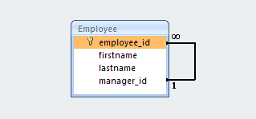

@ManyToOne(cascade={CascadeType.ALL})

@JoinColumn(name="manager_id")

private Employee manager;

@OneToMany(mappedBy="manager")

private Set<Employee> subordinates = new HashSet<Employee>();

